ANKUSH GAUTAM

22103307
B9
QUESTION 2

ANSWER::

#include <iostream>
#include <cmath>
bool isPrime(int num) {
if (num <= 1) return false;
if (num <= 3) return true;
if (num % 2 == 0 || num % 3 == 0) return false;
for (int i = 5; i * i <= num; i += 6) {
if (num % i == 0 || num % (i + 2) == 0) return false;
}
return true;
}
void printPrimes(int limit) {
for (int i = 2; i <= limit; ++i) {
if (isPrime(i)) {
std::cout << i << " ";
}
}
std::cout << std::endl;
}

int main() {
int limit;
std::cout << "Enter an integer: ";
std::cin >> limit;

if (limit < 0) {
std::cout << "Please enter a non-negative integer." << std::endl;
return 1;
}

std::cout << "Prime numbers up to " << limit << ": ";
printPrimes(limit);

return 0;
}

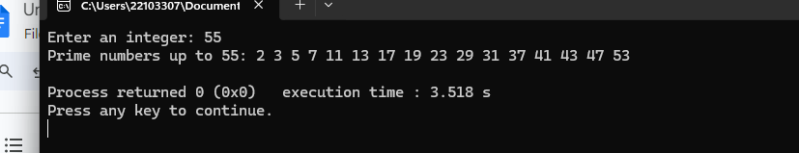

QUESTION 1

ANSWER::
#include <iostream>
#include <vector>
#include <iomanip>

using namespace std;

void printPolynomial(const vector<int>& coefficients) {
int degree = coefficients.size() - 1;
for (int i = degree; i >= 0; --i) {
if (coefficients[i] != 0) {
if (i != degree) {
cout << (coefficients[i] > 0 ? " + " : " - ");
} else if (coefficients[i] < 0) {
cout << "-";
}
cout << abs(coefficients[i]);
if (i > 0) {
cout << "x";
if (i > 1) {
cout << "^" << i;
}
}
}
}
cout << endl;
}

vector<int> calculateDerivative(const vector<int>& coefficients) {
vector<int> derivative;
int degree = coefficients.size() - 1;
for (int i = degree; i > 0; --i) {
derivative.push_back(i * coefficients[i]);
}
return derivative;
}

int main() {
int degree;
cout << "Enter the degree of the polynomial (0 to 5): ";
cin >> degree;

if (degree < 0 || degree > 5) {
cout << "Invalid degree. Please enter a degree between 0 and 5." << endl;
return 1;
}

vector<int> coefficients(degree + 1);
cout << "Enter the coefficients from the highest degree to the constant term:" << endl;
for (int i = degree; i >= 0; --i) {
cout << "Coefficient of x^" << i << ": ";
cin >> coefficients[i];
}

cout << "Polynomial: ";
printPolynomial(coefficients);

vector<int> derivative = calculateDerivative(coefficients);

cout << "Derivative: ";
if (derivative.empty()) {
cout << "0" << endl;
} else {
printPolynomial(derivative);
}

return 0;
}

